Congratulations on your decision to pursue improved oral health with Invisalign!
Please read this worksheet carefully and make sure to clarify any questions you may have regarding your Invisalign treatment with our team.

The start of treatment:
- Records (photos, 3D x-ray, and 3D scan) will be gathered to properly diagnose your treatment and start the process of fabrication for your first series of aligners.
  - The majority of patients have additional scans taken at the end of their first series of aligners in order to fabricate additional series of detailing aligners.
  - Your individual treatment time that was estimated at your treatment consultation is not based on the number of aligners you receive in your first series. Many people receive 3-4 series of aligners before completion.

- The process of scan submission, digital tooth set-up, aligner fabrication, and delivery takes 6-8 weeks. Your appointment will be scheduled for 6-8 weeks after your initial scan. If the aligners come back sooner, we will make an earlier appointment for you.

- At your next appointment, attachments will be bonded to your teeth as shown below, with placement and number varying on your specific case and movements, and also according to your specific preferences.

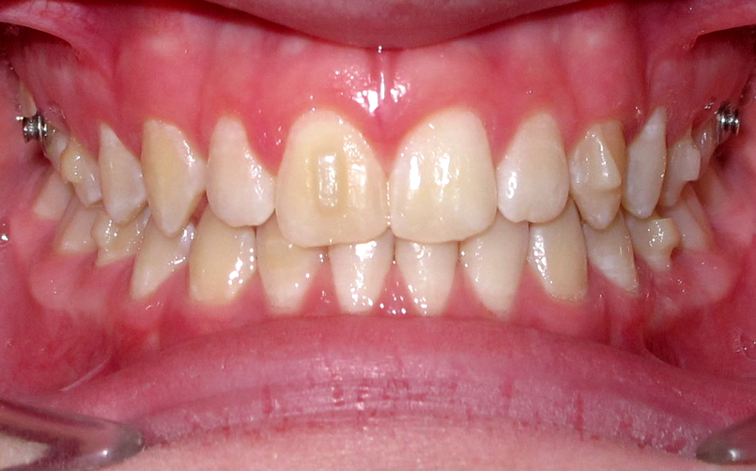

Treatment progress:
- The key to success with clear aligner treatment is full-time wear. Make 20-22 hours of aligner wear your daily target.
  - Try to avoid leaving the aligners out of your mouth for longer than 30 minutes at a time.

- Line the aligners up with your teeth and push them or up towards your gums. Ensure the aligners are completely seated on your front and back teeth. Then, bite with a chewie all along your teeth.
  - Chewies should be used each time the aligners are inserted to ensure complete seating.
  - Patients who use chewies regularly during treatment get more predictable results!!
  - Biting the aligners into place instead can cause distortion and unwanted tooth movements.

- The aligners should fit tightly over the teeth so that no space is visible at the edge of the teeth. If a gap exists, chewies should be used until the aligner fits properly.
  - Bite down on the chewie and hold in the area where the aligner needs to fit better for 5 seconds, then release. Repeat this process for 10 minutes at a time, up to three times per day, until the gap is reduced.
  - If you have a history of TMJ, and the chewies seem to be aggravating your jaw symptoms, use steady finger pressure instead to push the aligner in place.
  - Please call the office if you have concerns or questions about the fit of your aligners.

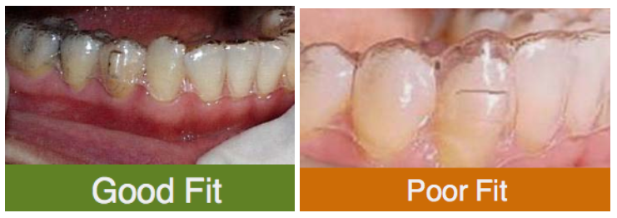

- The aligners are numbered in the order they are meant to be worn. Your aligners will be changed on a weekly basis, unless otherwise specified by the doctors. The most important indicators of your readiness to change into your next aligner are your compliance and the “tracking” of your aligners. In order to switch to the next aligner:
  - You wore your aligners for 20-22 hrs/day for the required number of days
  - There are no significant gaps between the aligner plastic and your teeth
  - You used your accelerating device (Acceledent, OrthoPulse, etc) daily for a minimum of 20 minutes/day with the aligners in place if indicated to do so.
  - If the above conditions are not met, proportionally increasing the time with your current aligner is recommended before moving forward.

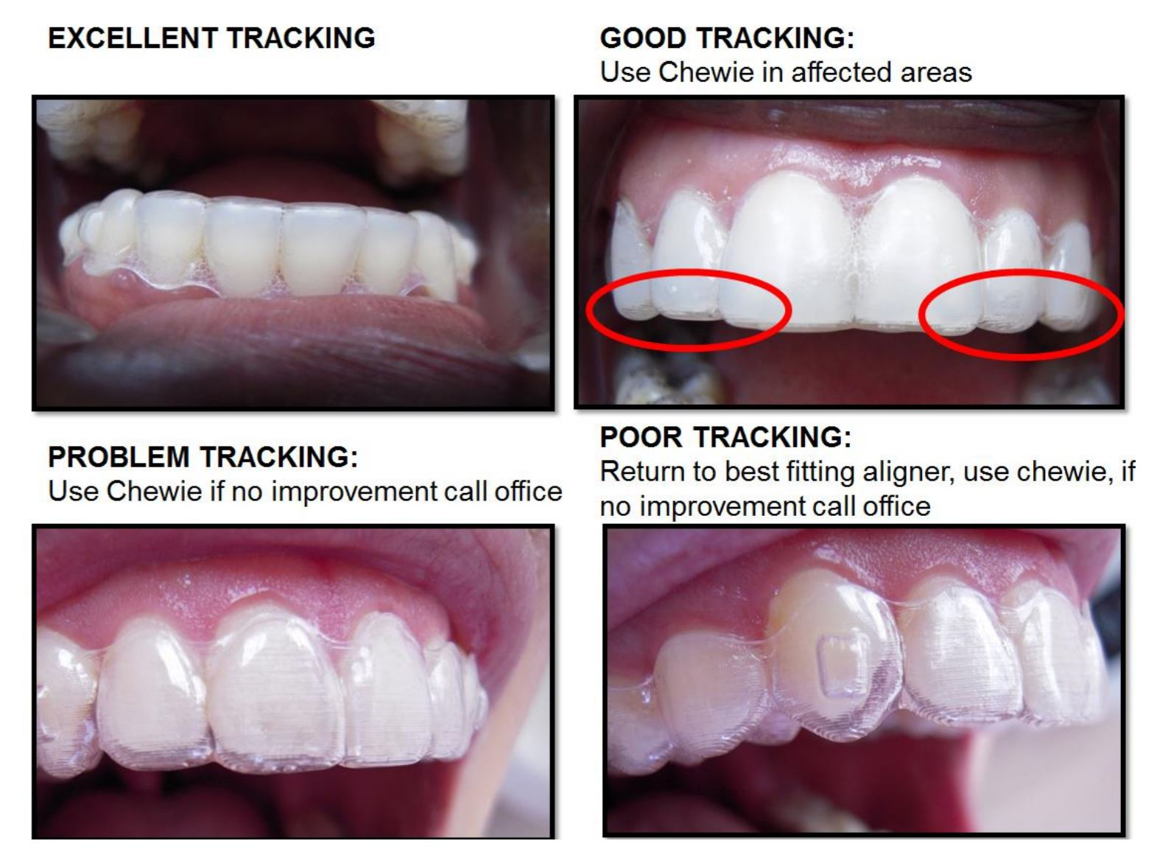

- If you anticipate an upcoming trip or event during which you will not be able to wear your aligners full-time, you may go into a "holding pattern" where you wear your aligners exclusively during sleeping hours to hold your teeth in place. Only move forward to the next aligner when you are able to wear the current aligner full-time again for the designated number of days.
  - Your teeth will move back to their original positions and have a hard time fitting into your aligners if you do not wear your aligners at all for any given length of time.

- A scan/consultation appointment with the doctor will be scheduled 3 aligners prior to the end of each series. It is crucial not to miss this appointment, as you may otherwise run out of aligners before your next series of aligners can be fabricated.
  - When you reach the final aligner in your series, you must continue wearing it to prevent relapse of your original tooth position.
  - Subsequent series are called “Refinement” aligners; they fine-tune the position of your teeth and bite.

- Your speech may initially be affected by the relationship between your tongue and your aligners. This will take a few days to get used to and return to normal. Practice reading and singing out loud!

- Soreness and tooth mobility are normal side-effects of tooth movement
  - Use of Tylenol (Acetaminophen) is recommended as needed. Ibuprofen/Motrin (Advil) and other NSAIDS interfere with tooth movement and are discouraged.
  - Tooth accelerating devices such as Acceledent, OrthoPulse, etc, have the added benefit of decreasing soreness and discomfort from tooth movement. We recommend using these devices as often as needed for pain relief, especially at the start of a new aligner.

- Use the “My Invisalign” app to track your progress and receive text reminders for when to change your aligners!

Possible additional features to your aligners:
- You will be emailed a copy of your “Clincheck.” This is your tooth movement plan. Attachments will appear red for easy reference, but are always tooth-colored when placed.

- Bite turbos are areas of raised plastic in your aligners behind your front teeth. They help to correct deep bites and prevent front-tooth interferences.

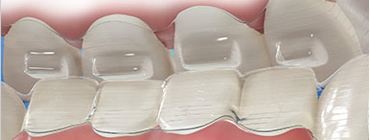

- Occlusal attachments are areas of raised plastic in your aligners on the biting surfaces of your back teeth. They help correct open bites and bring front teeth closer to each other.

- To help align your bite, elastics (also known as rubber bands) may be prescribed. They may attach to slits in your aligners or hooks bonded onto your teeth. They are to be worn 20-22 hours per day with your aligners unless otherwise specified.

- Sometimes, a small amount of “sanding” may be prescribed in between the teeth to correct black triangles or tooth-size discrepancies. This is called interproximal reduction (IPR). IPR can also help make space for crowded teeth.

Caring for your Invisalign aligners:
- Never eat or drink anything but water with your aligners in place.

- Aligners should be removed for brushing and flossing. Brush the inside of the aligners with your toothbrush and cold water (never hot water), or with baking soda and water.
- Use fluoride toothpaste for brushing your teeth at least twice a day.

- When eating or drinking, remove your aligners and place them into the case provided for safe keeping. Do not place your aligners in your pocket or into a napkin as this will lead to damage or accidental discarding of the aligners.

- If you are unable to brush/floss after meals or snacks, keep a water bottle handy and rinse your mouth after eating. Aligners should be “crystal clear” at all times. If aligners are cloudy, this is an indication of plaque accumulation, which can be damaging to the teeth, leading to scarring/decalcification and cavities on your teeth.

- Retainer Brite cleaning tablets (or denture cleaner) may also be used in addition to brushing the aligners to keep them free of mineral deposits from the saliva. Place the aligners in cold water with a cleaning tablet to soak for about 20 minutes. Brush and rinse the aligners before re-inserting into your mouth.

- If you have a rough area or spot on your aligner that is irritating your lips, cheeks, or tongue, use a clean emery board to smooth the area (we will provide one at your aligner delivery appointment).
  - You may also use orthodontic wax to cushion irritating areas against your tissues.
  - If you are still experiencing discomfort to your oral tissues, please call the office.

- It is best to avoid clenching, squeezing, or grinding on the aligners. Keep your jaws relaxed instead.

- If you are having trouble removing your aligners, the easiest technique is using your finger tip/nail to dislodge the aligner from the inside in the back on both sides, and then pulling from the front. Pulling on the front without dislodging the aligner from the back first can cause stress and aligner fracture/cracking.
  - If you are still having trouble removing your aligners, a special tool is available to help – just ask!
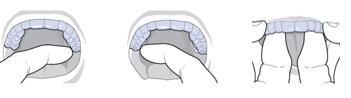

- Keep all aligners in the current series you are using. Do not throw any of them away until you receive your next series of aligners.

- If your current aligner becomes cracked or is lost before the completion of the one week of wear, either move backward or forward onto your previous or next aligner and make up for the lost days with extra wear.

- If you happen to lose track of which aligner number you are currently wearing, hold your aligner against a white background and search for the number following the U (upper) or L (lower).

- At the completion of your Invisalign treatment you will receive Invisalign retainers and a fixed lower lingual wire.

- Invisalign sets a time limit for all cases. For teenagers and adults, this time limit is 5 years; for young children, this time limit is 18 months. In the unlikely event that your treatment extends beyond these time limits, there may be an additional treatment fee for continuing your treatment.

We are committed to achieving the most successful treatment result for you with your cooperation! Please call or text us at 415-459-8006 or visit our website www.marinortho.com for any further questions, advice or support.

You are on your way to a healthy, beautiful smile!

